Making Qualtrics Surveys Anonymous

Qualtrics automatically collects information and puts it in your data set that could be personally identifying (e.g., geo-location, IP address). You must specifically tell Qualtrics that you do not want this information. The way to do this is to “anonymize” the survey. The steps for anonymizing your Qualtrics survey are listed below. In your HREB proposal, you must indicate whether you have selected the option to anonymize your survey. If you do not specify, the HREB reviewer will assume that you have not done so and will review your proposal based on this assumption. This may mean that you are asked to provide additional information or that you are asked to submit a longer proposal.

Steps for Anonymizing Surveys in Qualtrics:
- When you have your survey open in Qualtrics, click on the “Survey Options” button.

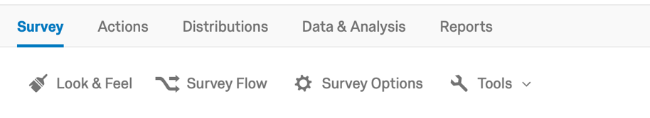
- Then scroll down to Survey Termination and select the Anonymize Responses option.
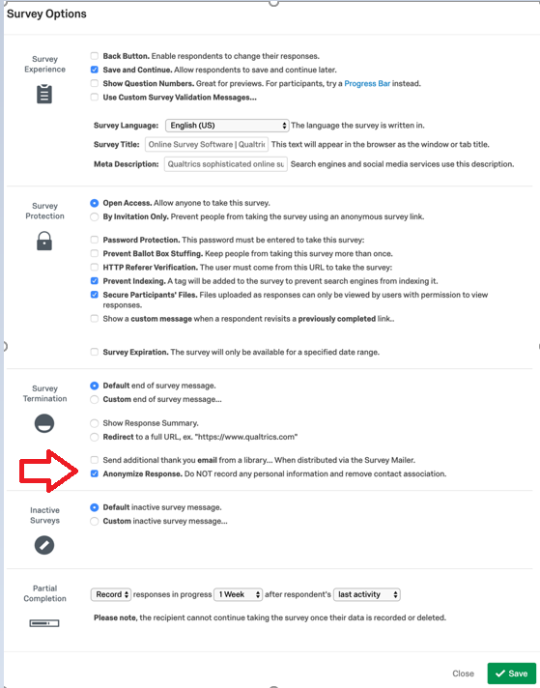

- Click Save.

Also, you want to keep in mind, that when you develop an anonymous survey in Qualtrics, you must design your survey so that there are no questions or combinations of questions that can identify your participants. For example, you cannot collect email addresses of participants if you are conducting an anonymous survey. In terms of demographic variables, you must be careful not to ask questions that can by themselves or when combined with other demographic information identify individuals. For example, if you are surveying college students and you ask for age and racial background, there may be only one 72 year old, Native American in the university. This combination of questions would make this individual personally identified. So when designing your survey, consider whether the questions you ask can potentially lead to personally identifying individuals. If so, modify or change your questions to avoid this problem.

